First,fire smoke alarm base structure description
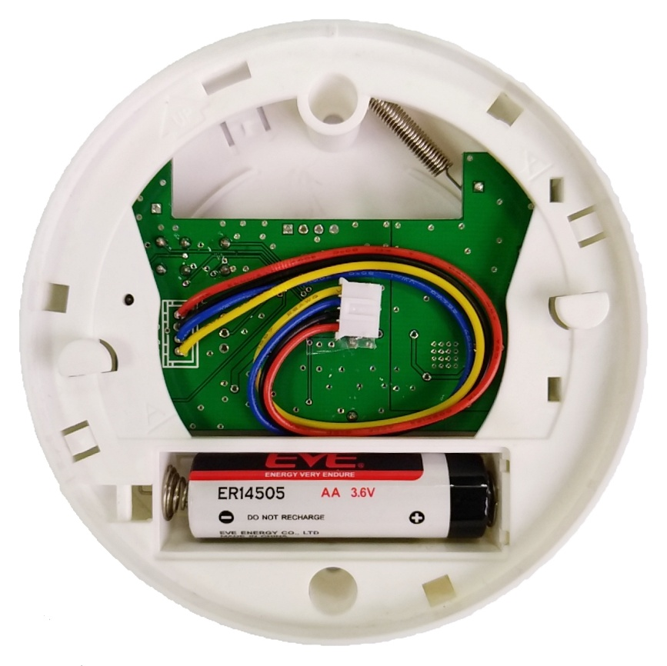
Marking line

Screw hole
Battery compartment
“A” Marking line
Screw hole
Cable

Second, the smoke alarm base installation
- Remove the base of the alarm.
- Install the ER14505 battery into the battery compartment. Pay attention to the positive and negative electrodes
- To ensure that the alarm is aesthetically pleasing when mounted on a ceiling or wall, the "A" marking on the base can be positioned in the direction of installation when ceiling mounting is used; if it is wall mounted, the "A" marking is made Install in a horizontal position. (See Figure 2)
- Once the appropriate smoke alarm installation location has been selected, secure the base to the ceiling. Secure the base with the supplied screws. Note: The hole is 5 mm (3/16 inch). (see picture 1)
If it is a wall mount, position the base horizontally on the wall, making sure the "UP" text and arrows are facing up. (See Figure 2)
- When installing the battery, press the red warning lever into the battery case with the battery and install the battery. (See Figure 3)
CAUTION ! If the red warning lever is not pressed into the battery compartment by the battery, the alarm cannot be attached to the base.
- Connect the base cable to the alarm. (See Figure 4)
- Alignment marks are placed on the edges of the base and the alarm. (See Figure 5)
After installing the base, first connect the base cable to the alarm, then attach the alarm to the base and align it with the mark. Turn the alarm in the direction of the "ON" arrow on the alarm housing until the alarm is locked to the base.
- After the installation is complete, test the alarm. Press and hold the test button for a minimum of 8 seconds, at which point the alarm should enter the "test" alarm state.

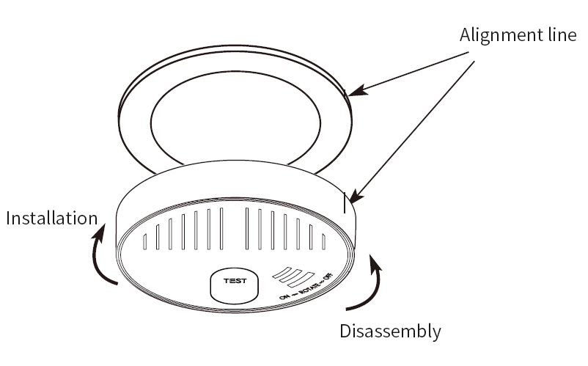
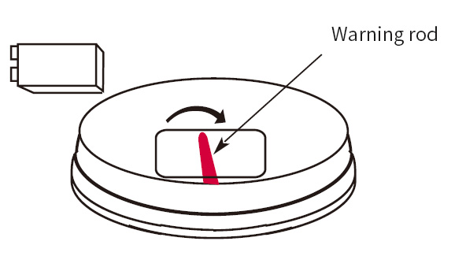
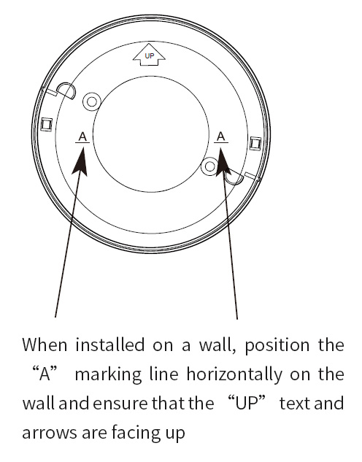
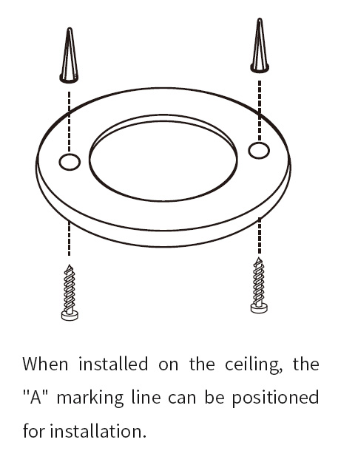
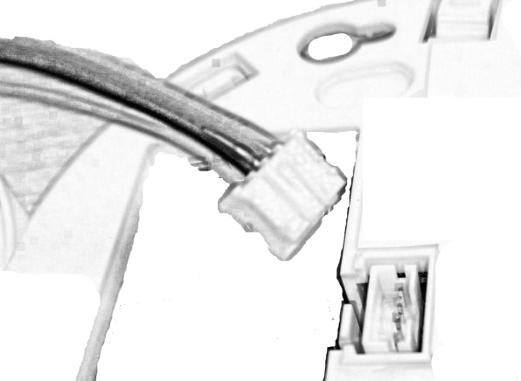
Figure5
Figure4
Figure3
Figure2
Figure1

Third, random accessories
3.6 volt battery | 1
Mounting screws | 2
Expansion rubber sleeve | 2
User guide | 1
Certificate | 1

Fourth, technical information
Product number | XA-LoRa-ED01
Interface Type | LoRa
Communication frequency | 433MHz
Communication distance | 2km
Transmit power | 20dbm
Receiving sensitivity | -124dbm
Communication rate | 4800bps
Configuration interface | Configuration parameters can be configured through the serial port
working environment | -25℃～70℃，0%～95%RH
Operating Voltage | DC2.0～3.6V
Battery capacity | 2200mAH(AA)
Working current | Emission current ：120mA； Receiving current ：20mA；  Sleep current ：2uA
Shell | PC plastic case
size | 101.6mm （ diameter ）* 22.2mm（ thickness ）

